

**RAMANUJAN COLLEGE, DELHI UNIVERSITY**

**PRACTICALS**

**NUMERICAL OPTIMIZATION**

**Submitted By: SAHIL**

**Submitted To: Dr.Akash**

**Roll no : 20221474**

**Semester – III**

**Course-BSc (Hons)**

**(Computer Science)**

1. WAP for finding optimal solution using Line Search method.

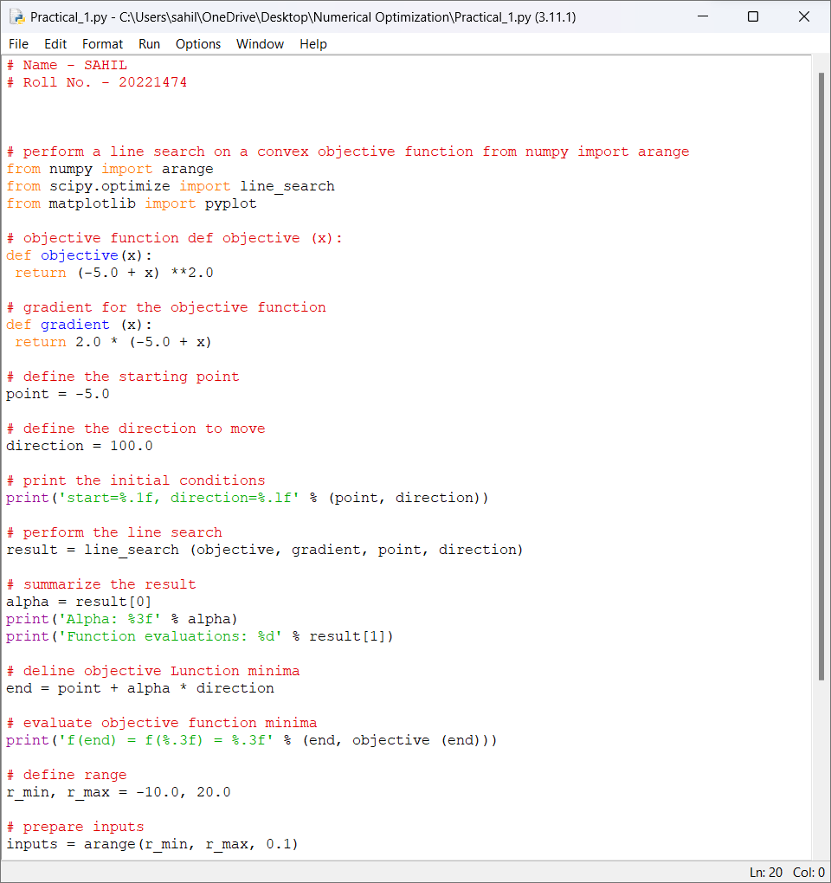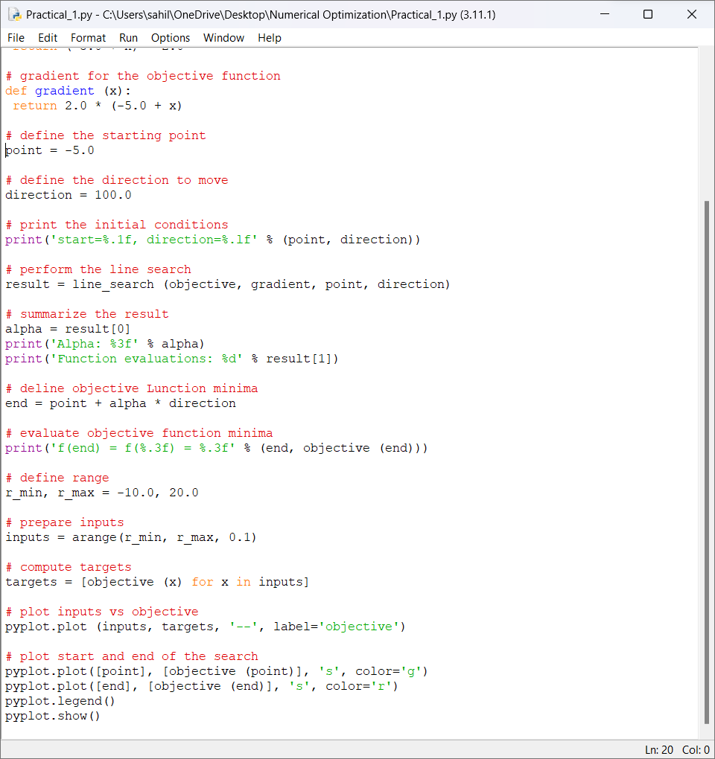

OUTPUT:

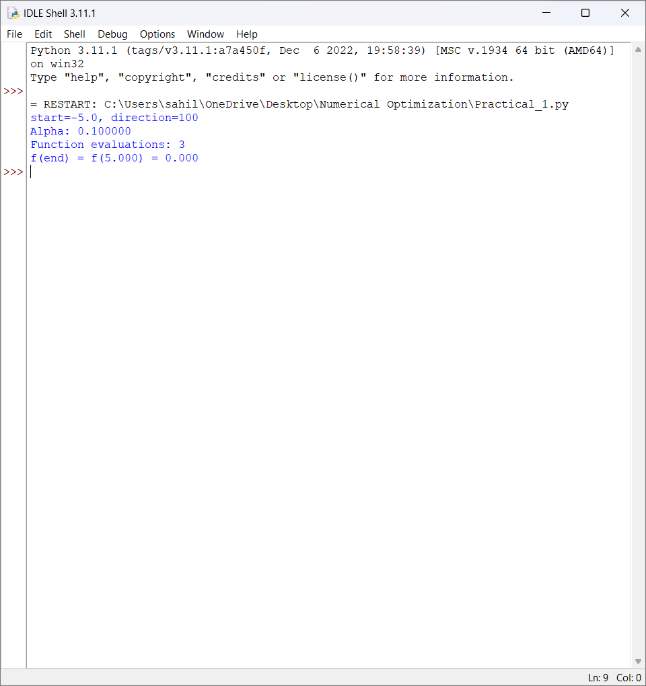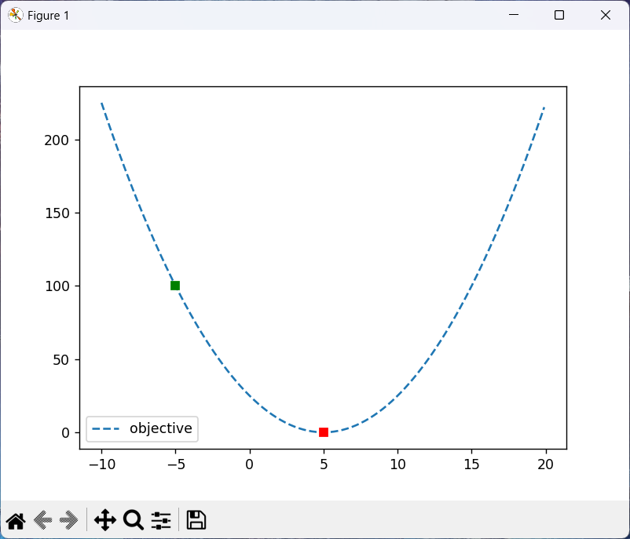

1. WAP to solve an LPP graphically.

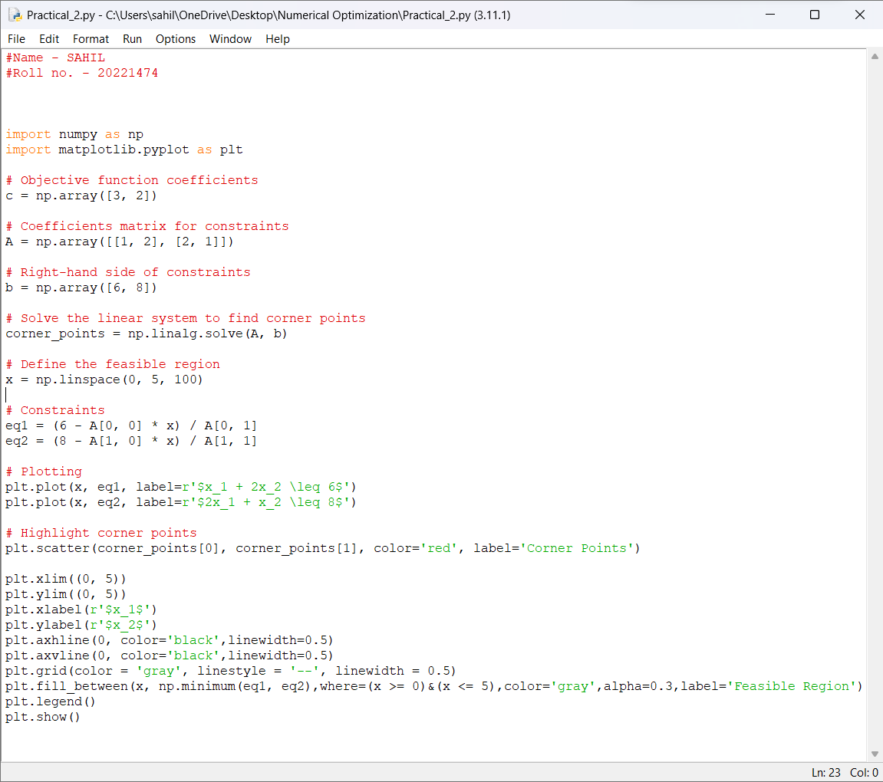

OUTPUT:

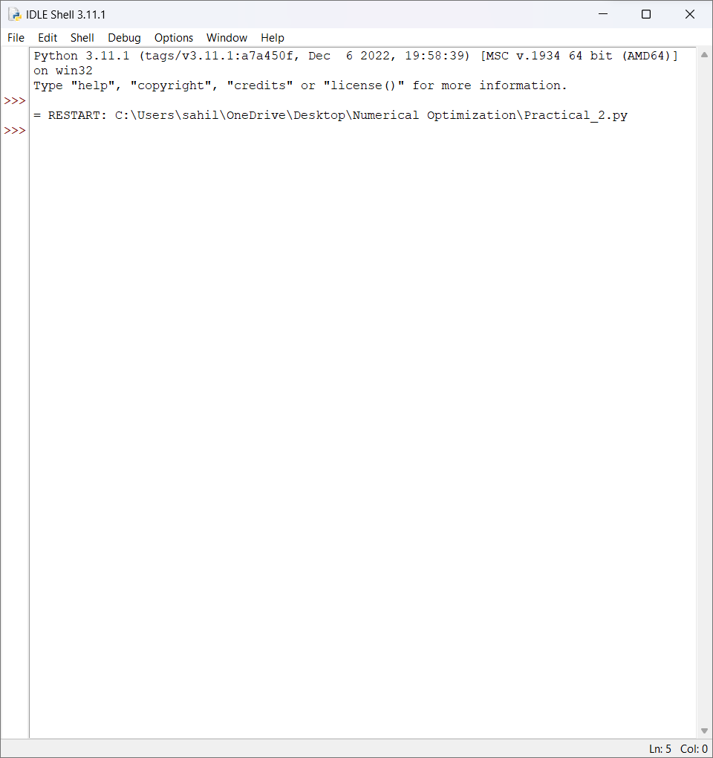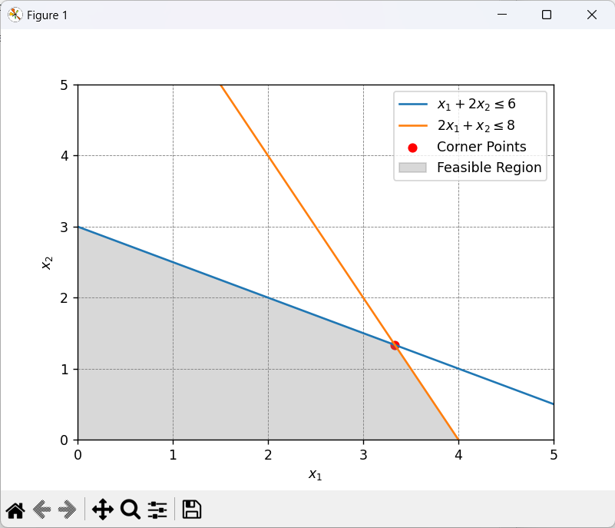

1. WAP to compute the gradient and Hessian of the function.

𝑓(𝑥) = 100(𝑥2 − 𝑥1** 2) ** 2 + (1 − 𝑥1)** 2

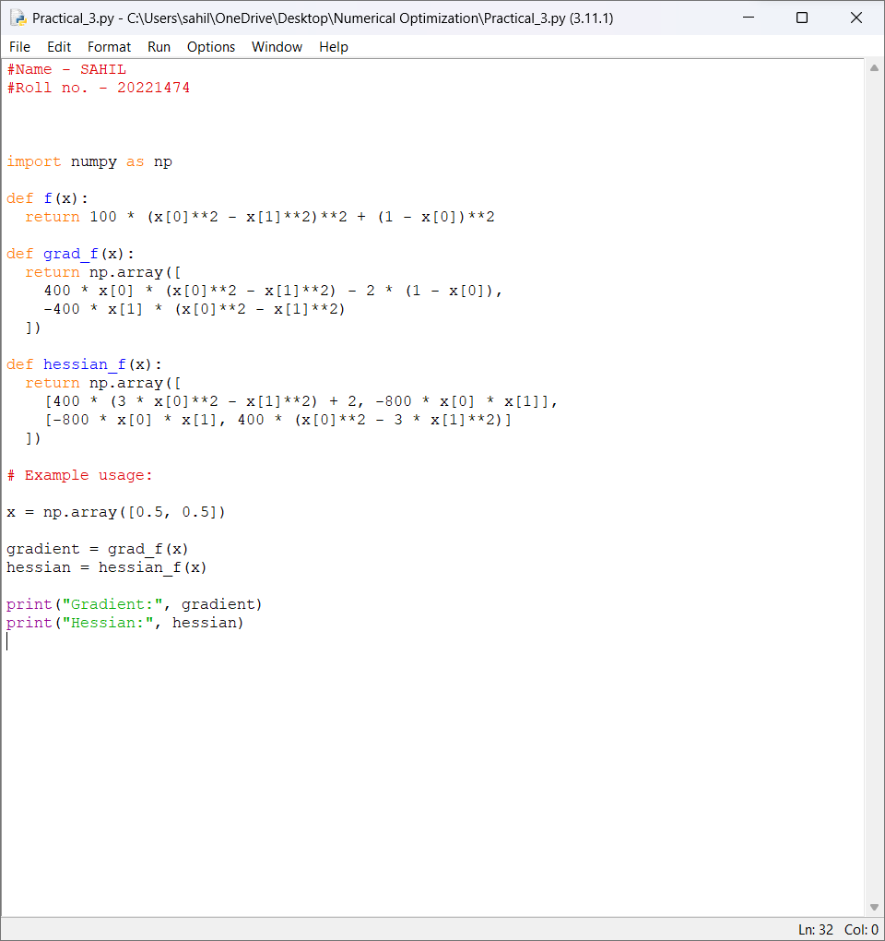

OUTPUT:

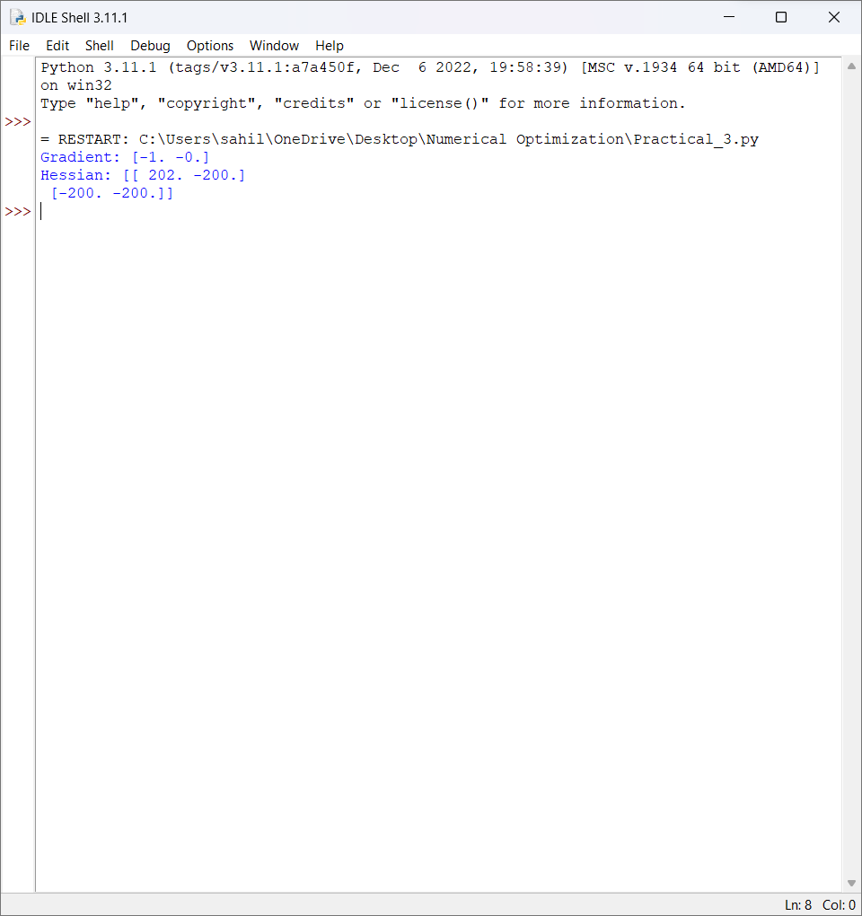

1. WAP to find Global Optimal Solution of a function.

𝑓(𝑥) = −10𝐶𝑜𝑠 (𝜋𝑥 − 2.2) + (𝑥 + 1.5) 𝑥 algebraically

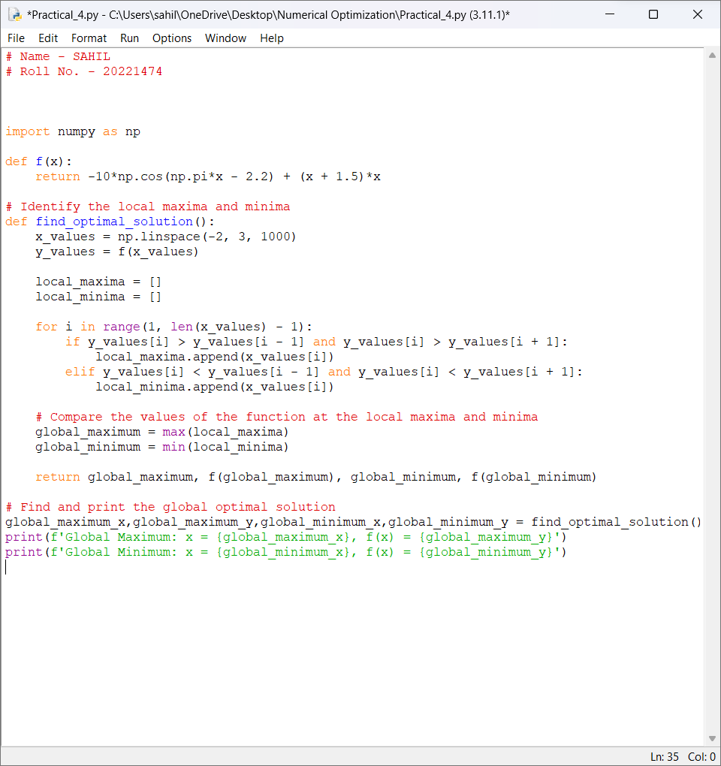

OUTPUT:

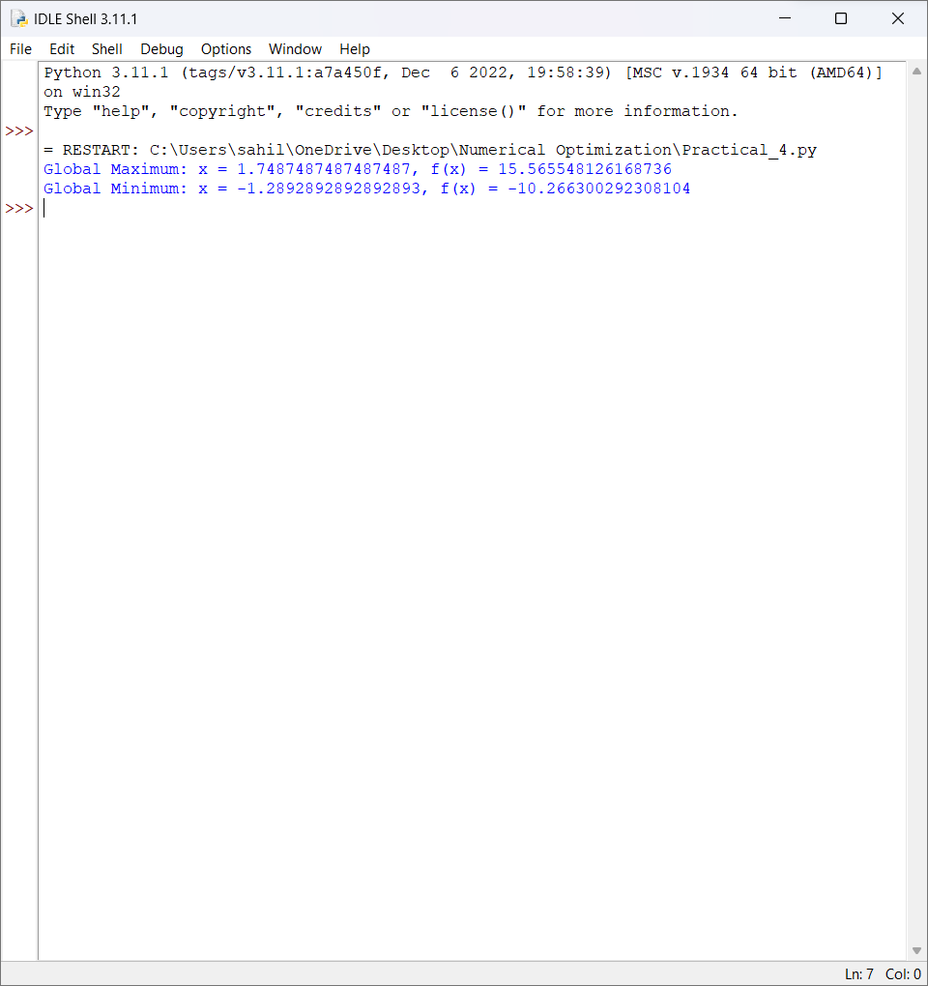

1. WAP to find Global Optimal Solution of a function.

𝑓(𝑥) = −10𝐶𝑜𝑠 (𝜋𝑥 − 2.2) + (𝑥 + 1.5) 𝑥 graphically

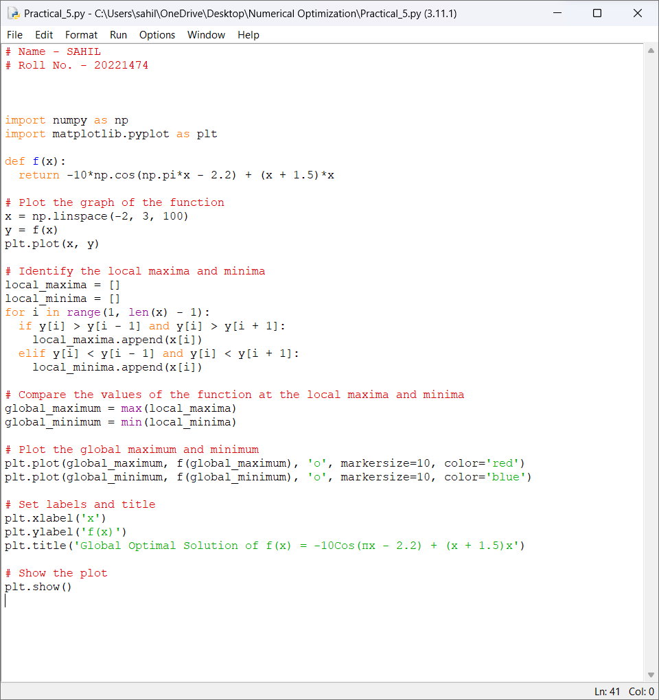

OUTPUT:

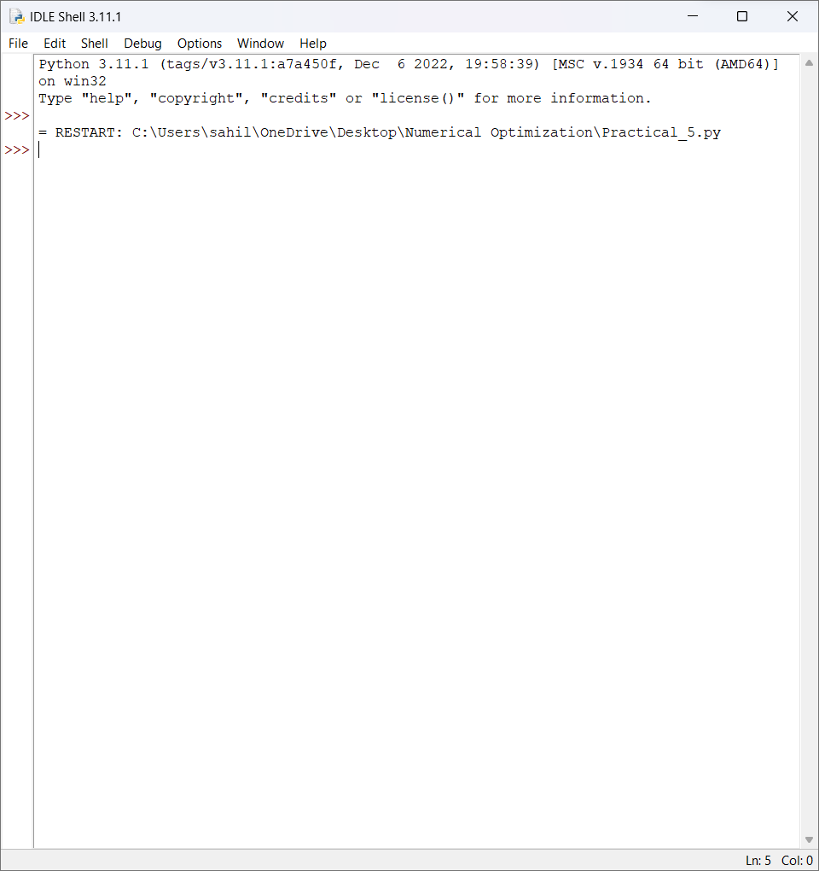

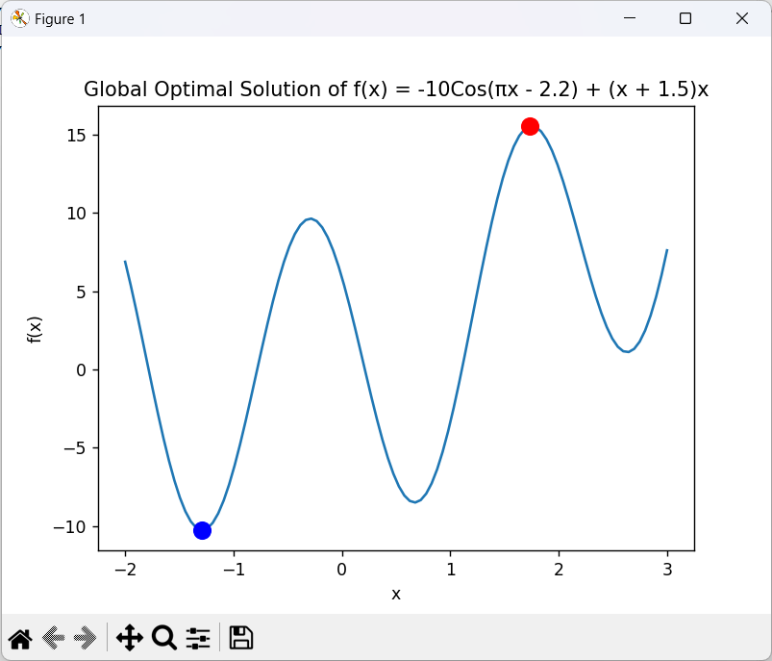

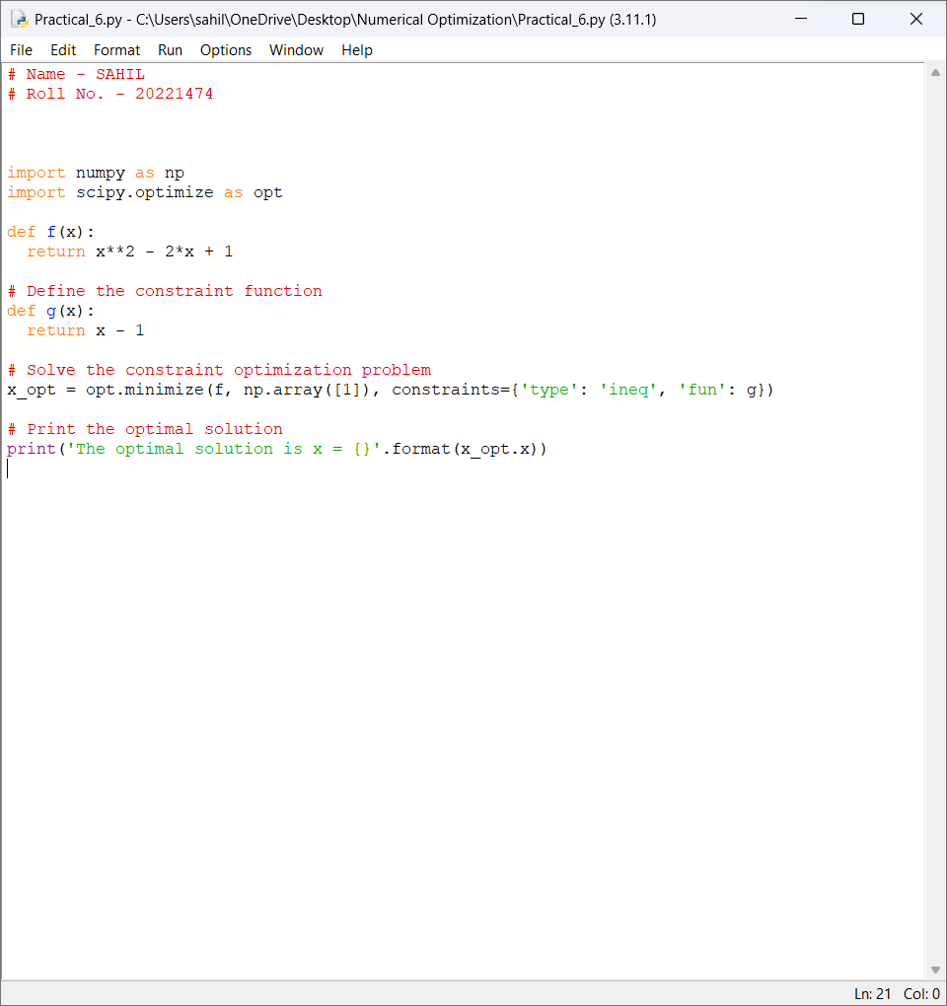

OUTPUT:

